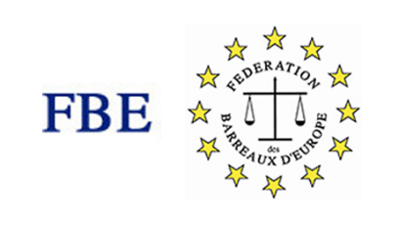 | 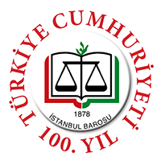

REGISTRATION FORM
JOINT EVENT ON THE OCCASSION OF THE INTERNATIONAL WORKING WOMEN’S DAY
11 MARCH 2023
ISTANBUL
Istanbul Bar Association
Conference Hall
Beyoğlu
Name&Surname

Bar Association

Address

e-mail

Mobile

I will attend the sessions on 11 March.
(including coffee breaks and lunch)
75 Euros
I will attend the dinner on 11 March.
(optional)
56 Euros
Half-Day City Tour with lunch
(optional)
9.00-14.00
(will be organized for a group of minimum 10 people)
100 Euros

The language of the event is Turkish and English with interpreting service available.
The registration fee includes participation to the event (with 2 coffee breaks and lunch on 11 March).
Filled-out registration forms shall be sent to information@istanbulbarosu.org.tr with a proof of payment no later than 6 March 2023.
Payment details:
Please mention “FBE-Istanbul Bar Joint Event” in your transfers.
Account Holder: İstanbul Barosu
Bank: Vakıfbank İstanbul Adalet Sarayı Şubesi
IBAN: TR330001500158048000474956
Swift TVBATR2A

