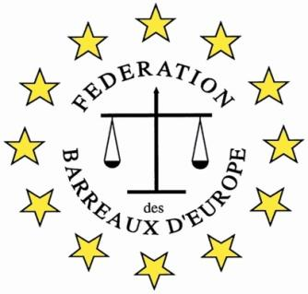

**FBE 6th International Young Lawyers’ and Law Students’ Human Rights Oratory Competition, Antwerp/Belgium 2025**

**WHERE?**

**In Antwerp, Belgium**

**WHEN?**

**9 and 11 October 2025**

**WHO?**

**Law Students and lawyers up to 5 years qualified and age 35**

**WHY?**

**The Competition is a great opportunity to:**

* **practice and improve oratory skills**
* **learn to present a case to an international audience of lawyers**
* **develop legal English and general oral English skills**
* **meet with lawyers from jurisdiction across Europe**
* **and** **enjoy your visit to Antwerp**

**THE ORGANIZATION**

**The Competition is organized by the European Bars Federation (FBE)/ its Human Right Commission and will be hosted by the Antwerp Bar.**

**WHAT YOU WILL DO**

**Prepare a 10 minutes speech on: “Can the United Nations develop an effective international strategy to solve the current levels of migration” to be presented to an International Jury in Antwerp with other participants from different countries.**

**If selected amongst the four best contestants, defend a position against an opponent on another topic the following day.**

**HOW TO APPLY**

**Applications should be completed on the accompanying form and approved by your Bar Association. Please contact your Bar and send your application to the relevant person. The form must then be sent to:** [**fbehumanrightscompetition@gmail.com**](mailto:fbehumanrightscompetition@gmail.com) **by 12.00 midday on 12 September 2025**