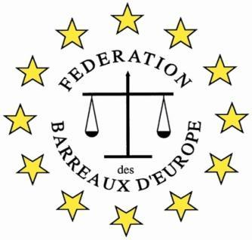

The FBE 7th International Young Lawyers’ and Law Students’
Human Rights Oratory Competition,
22 to 24 October 2026

Topic: "Strategic Litigation Against Public Participation (SLAPP) is a 21st Century instrument of law. What does this mean for the future of the legal profession.?"

Application Form
(.doc format)

The Bar
Participating Bar
Contact Person in the Bar
Phone (international format)
E-mail
The Participant
Participant
Phone
E-mail
Additional Notes
Please tell us about the candidate

Candidates’ applications should be approved by the Bar Association.

Please contact your Bar and send your application form to a relevant person.

The Bar will send the application to the FBE HRC e-mail: fbehumanrightscompetition@gmail.com

Before 12.00 midday on Friday 19th September 2026.

